Summary for the testing of high-k scattering laser and FIReTIP laser

8/25/2025

1. The testing for high-k scattering laser
   1. The setup for the laser testing

Figure 1 shows the schematic of high-k laser system, which includes the CO2 laser, high-k laser and FIR laser measurement stage. The focus lens shown in Figure 1 is used to focus the CO2 beam into the high-k laser window, where the radius of window aperture is only about 1 mm.

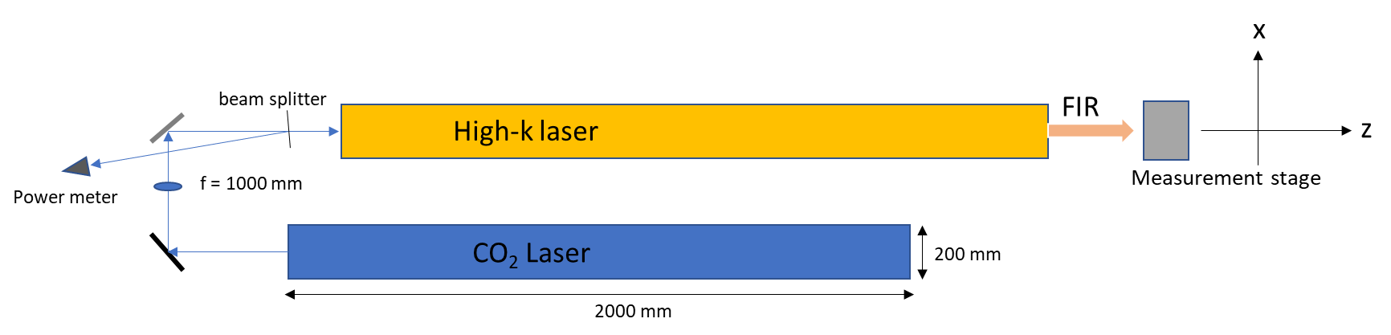

Figure 1. The schematic of optical setup for high-k laser testing

The Figure 2 shows the optical system between the CO2 laser and High k laser system, which using a focus lens to shrink down the CO2 beam size into high-k laser input window. The scanning stage shown in Figure 3 is set behind of the output window of high-k laser system, which is used to measured the beam profile. The control program is written in LabVIEW version, which is called Vlemx_SubviTest_SaveData_8.vi, as the front panel is shown in the Figure 4.



Figure 2.The Feed-in system between CO2 laser and FIR laser

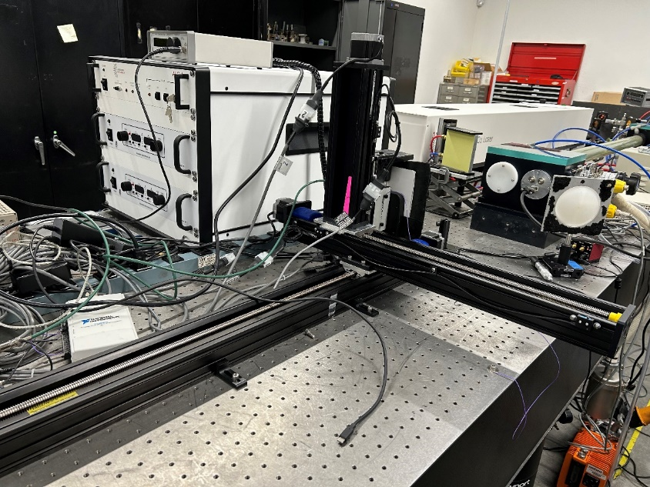

Figure 3.Scanning stage behind of the high-k laser output window.

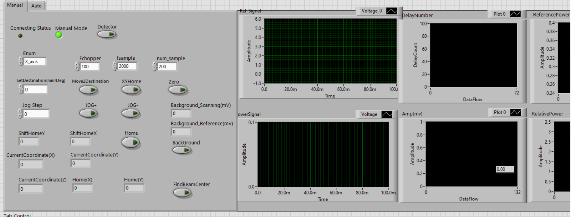

Figure 4. Scanning stage control program, which is named as Vlemx_SubviTest_SaveData_8.vi

* 1. The beam profile testing

Double check beam profile after laser window without any lens set in front of the output window (Testing on 4/16/2025)

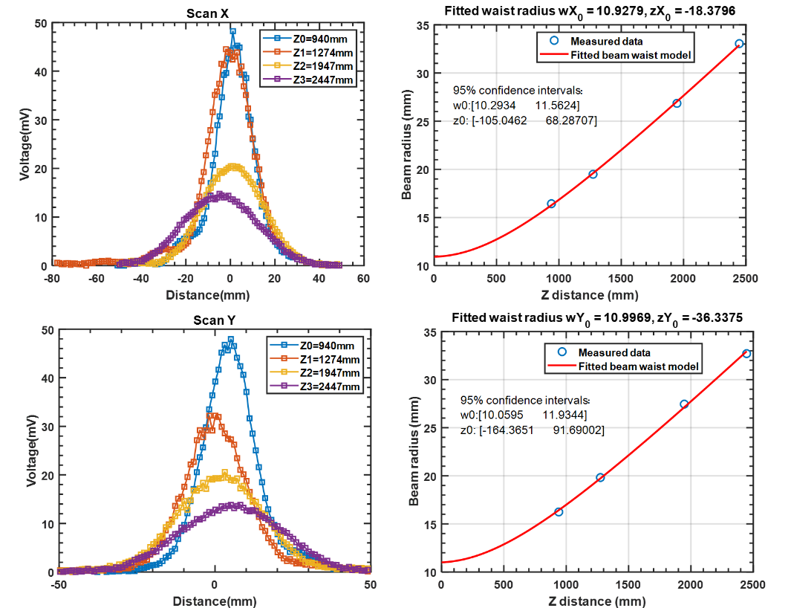

Figure 5.First scanning. Data from SCAN_TEST_2D_04_16_2025_test2_0-3. Fitting code: [waists(ii),~]=beam radius(sXm,sYm),here z distance refers the distance from the laser window to the measured position.

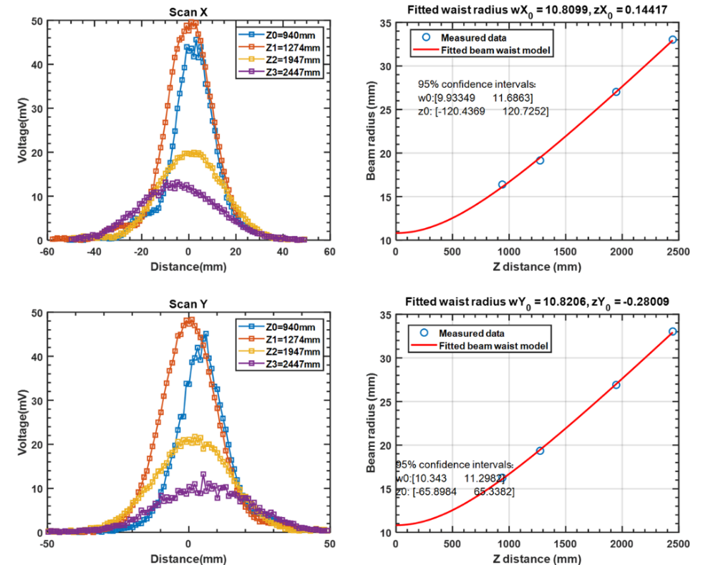

Figure 6. Second scanning, data from SCAN_TEST_2D_04_16_2025_test1_0-3.

According to the testing results, we can estimate that the beam waist radius of FIR laser: wx0 = [10.8,10.92] mm, zx0 = [-18.379, 0.1] mm; wy0 = [10.8,11] mm, zy0 = [-36.33, -0.2] mm. Here, wx0 refers to the waist radius in x direction (as shown in Figure 1), so does wy0. The z-distance refers to the distance from the laser window to the measurement point. The beam waist radius is approximately 10.8 mm, located at the laser window.

* The beam profile stability under different running time

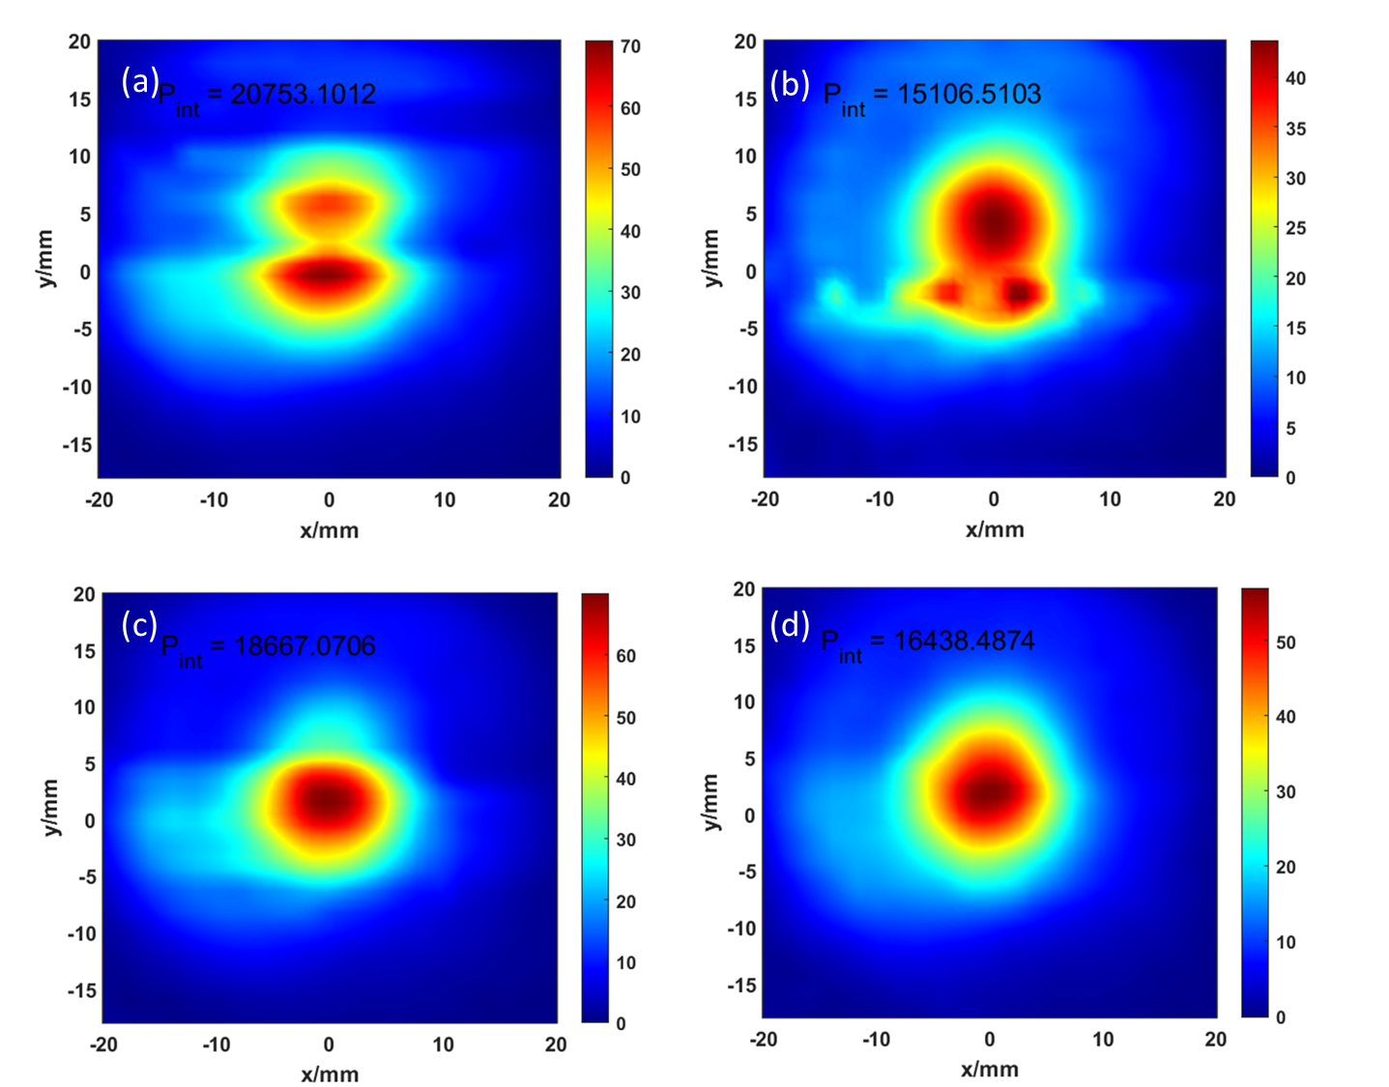

Figure 7.Measure beam profile with low flow normal CO2 pressure at different times. (a)2:53pm(b)3:08pm(c)3:17pm(d)3:29pm

The 2D beam profile is shown in Figure 7.The laser system turned on at 2:30 PM and then scanned the cavity to find the best cavity position at zCavity = 2.27 mm with formic acid gas pressure at 196 mTorr. Figure 7 shows the measurement at different time period, it finally stable at Gausses beam profile as shown in Figure 8.

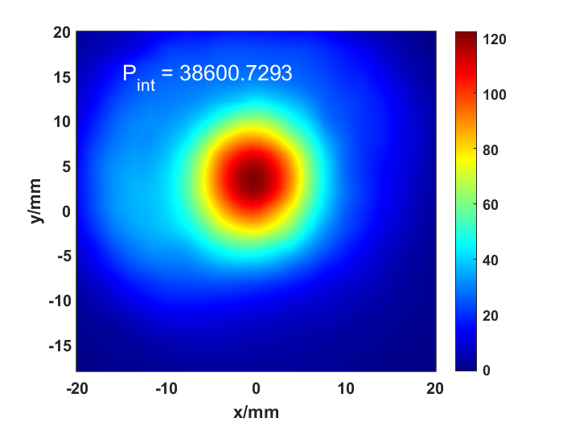

Figure 8.Measured at normal CO2 flow at 4:12 where zCavity =4.028 mm and formic acid gas pressure is 200 mTorr.

* 1. The intensity of the laser beam

The beam power of the high-k laser is around 45 mW (24/(5/9)~45), with a transmission ratio of about 5/9 at 693 GHz when the detector is covered with foam

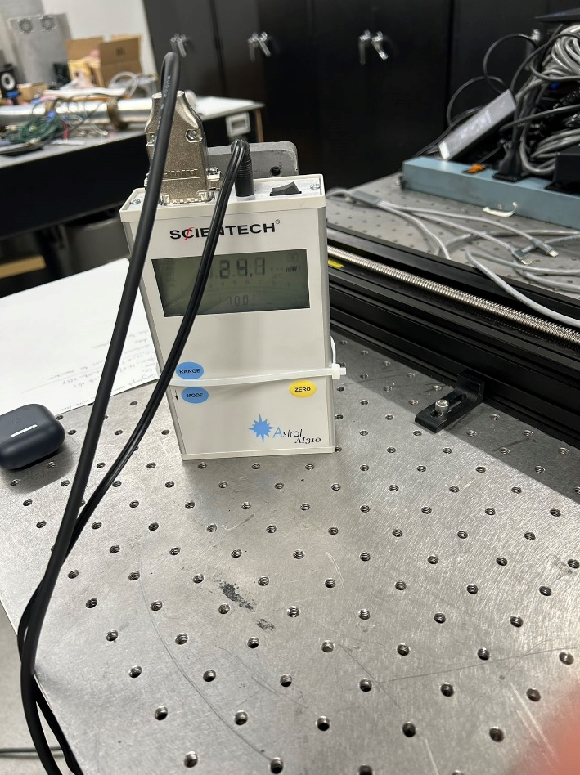

Figure 9. The absolute power of high k laser measured by Power meter with IR absorber foam.

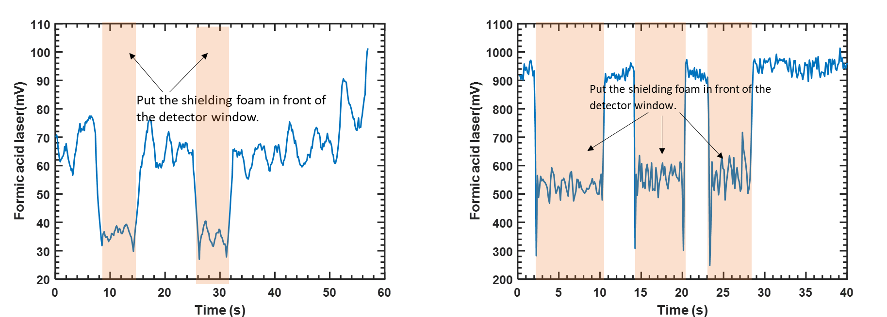

Figure 10. The testing transmission ratio of the cover foam on the detector. (left) Measure the transmission ratio by power detector under low beam power. (right)Measure the transmission ratio by power detector under high beam power.

* 1. The optimal formic acid gas pressure

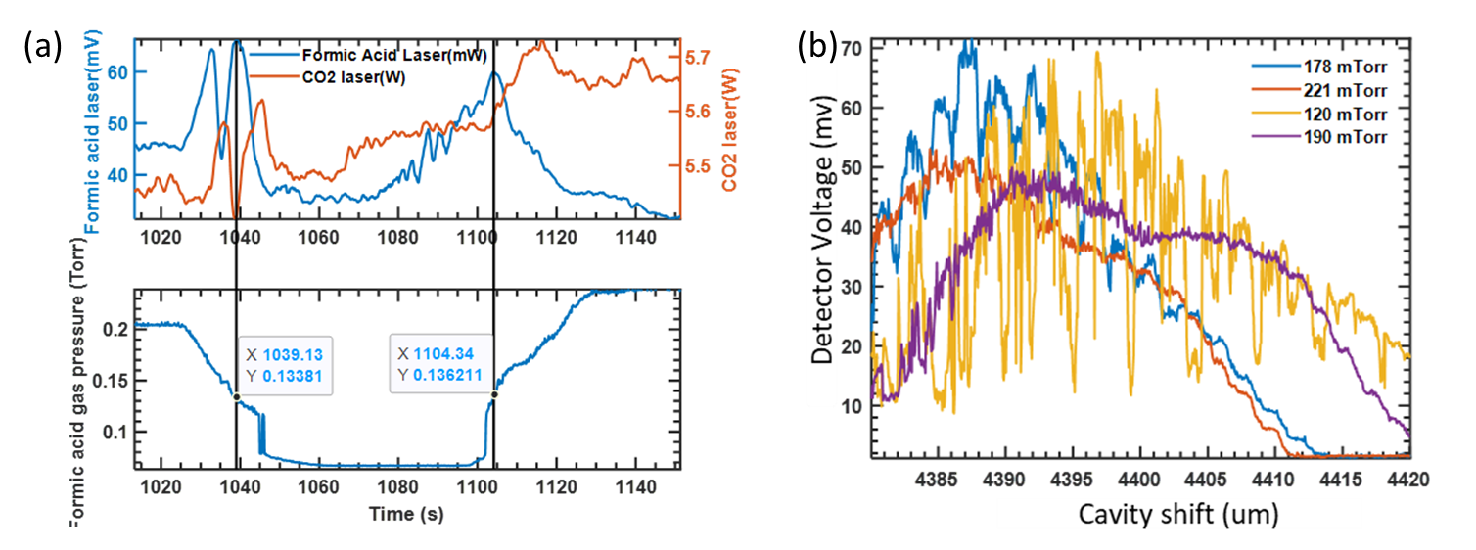

Figure 11.(a) Scanning the formic acid gas pressure. (b) Scanning the cavity at different formic acid gas pressure.

The optimal formic acid gas pressure for high-k laser should be above 190 mTorr to avoid the instability but below 250mTorr

* 1. The coupling lens with waveguide